ntroduction and Setting Up
Content
Discussion

Weather at Your Fingertips
Ever wonder how all those weather apps on your phone know exactly what's going on outside? It's not magic (although sometimes the weather feels that way!), it's thanks to something called an API.

What's an API?
Think of an API as a special messenger service. It allows different applications to talk to each other and share information. In our case, the weather API will act as our personal weather genie, providing us with real-time data like temperature, description, and maybe even a chance of rain (hopefully not while we're coding!).

Building Our App: Tools of the Trade
To build our weather app, we'll be using three key tools:
- HTML: This is the blueprint of our app, like the foundation of a house. It defines the structure and content layout. Imagine using building blocks like walls and windows to create the basic shape of our app.
- CSS: This is the interior decorator! CSS lets us style our app, choosing fonts, colors, and layouts to make it visually appealing and user-friendly. Think of it as painting the walls, adding furniture, and making the app look snazzy.
- JavaScript: This is where the magic happens! JavaScript adds interactivity to our app. It will allow us to fetch weather data from the API and dynamically update the information displayed on the screen. Imagine it as the electrical wiring that brings everything to life, letting us control lights, switches, and weather updates!

Choosing Our Weather API
There are many weather APIs out there, each with its own features and data offerings. Today, we'll be using a popular one called OpenWeatherMap (https://openweathermap.org/). It's a great choice for beginners because it has a free tier perfect for our project.

By the end of this lesson, you'll understand the basics of weather APIs and the tools we'll need to build our app. We'll even create an account on OpenWeatherMap and get our own API key, which is like a secret handshake that allows us to access their weather data.
Ready to unleash your inner meteorologist and build your own weather app? Let's get started!

Obtaining an API Key for OpenWeatherMap
Content
Discussion

Obtaining an API Key for OpenWeatherMap

Here's a step-by-step guide on getting your own API key for OpenWeatherMap:
- Head to OpenWeatherMap: Open your web browser and visit the OpenWeatherMap website: https://openweathermap.org/api.
- Sign Up for an Account: Click on the "Sign Up" button located in the top right corner of the webpage.
- Fill Out the Registration Form: Enter your email address, choose a username and password, and agree to the terms of service. Click on the "Create Account" button.
- Verify Your Email: You'll receive a confirmation email from OpenWeatherMap. Open the email and click on the verification link to activate your account.
- Access Your API Keys: Once your account is verified, log in to OpenWeatherMap using your username and password.
- Navigate to API Keys: Look for a section or menu labeled "API keys" or "My API keys". This might be located on your account dashboard or profile settings.

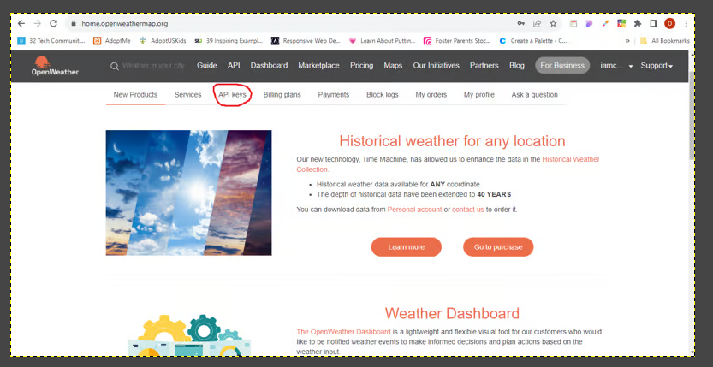

- Generate Your API Key:
- You might see a list of existing API keys (if you've created any before).
- Look for a button labeled "Generate" or "Create" to create a new API key.
- Give your API key a descriptive name (e.g., "WeatherAppProject") to help you remember its purpose.
- Click the "Generate" button.
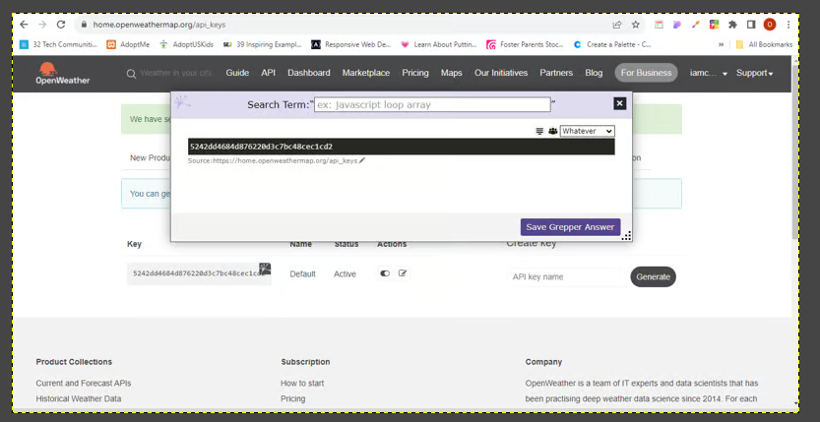
- Copy and Store Your API Key Securely: Your newly generated API key will be displayed on the screen.
- Important: Treat your API key like a password. Keep it confidential and don't share it publicly.
- Copy the API key and paste it into a secure location, like a password manager or a text file you keep private.
Congratulations! You now have your own API key for OpenWeatherMap, ready to use in your weather application. Remember, this key allows you to access their weather data, so treat it with care.

Building the User Interface (HTML & CSS)
Content
Discussion

Building the User Interface (HTML & CSS)

In this section, we'll create the foundation of our weather app using HTML and CSS. HTML will provide the structure and content layout, while CSS will bring it to life with styles.

Step 1: Setting Up Our Files
- Create a Folder: Make a new folder on your computer to store your project files.
- Create an HTML File: Inside the folder, create a new file named index.html. This will be the main file of our web application.
- Open the File in a Text Editor: Use a code editor like Visual Studio Code or a simple text editor like Notepad to open the index.html file.
Step 2: Building the Basic HTML Structure
Now, let's write some HTML code to define the basic structure of our app:
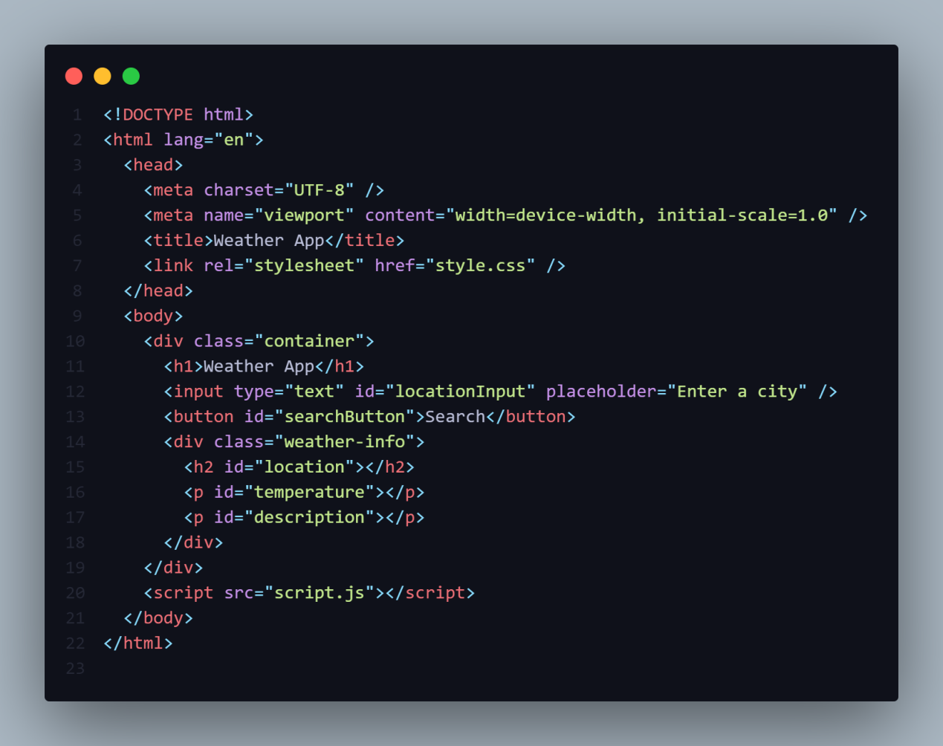

Step 4: Adding Basic Styling with CSS
Now, let's create a separate file to style our app using CSS.
- Create a CSS File: Inside your project folder, create a new file named style.css.
- Link the CSS File to Your HTML: In your index.html file, add a link tag inside the <head> section to reference the CSS file:
- Styling the Elements: In your style.css file, add some basic styles to make the app visually appealing:

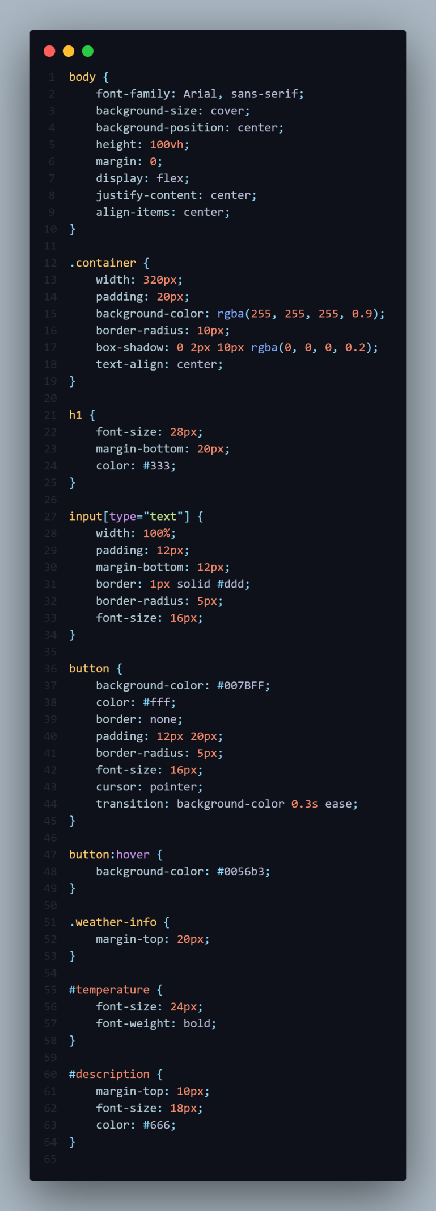
Fetching Data and Updating UI (JavaScript)
Content
Discussion

Fetching Data and Updating UI (JavaScript)

Now comes the magic! In this part, we'll use JavaScript to:
- Fetch weather data from the OpenWeatherMap API.
- Parse the JSON response data.
- Update the UI with the retrieved weather information.
Step 1: Including JavaScript
- Create a Script Tag: In your index.html file, add a script tag before the closing </body> tag to include your JavaScript code:
- Create a JavaScript File: In your project folder, create a new file named script.js to store your JavaScript code.
Step 2: Fetching Weather Data with JavaScript
Here's a breakdown of the JavaScript functionalities:
- Access User Input: We'll use JavaScript to get the city name entered by the user in the search bar.
- Construct the API Request URL: We'll build the URL to fetch weather data for the specific city, using the user input and our OpenWeatherMap API key.
- Fetch Data from the API: We'll use the fetch API in JavaScript to make a request to the constructed URL and retrieve the weather data.
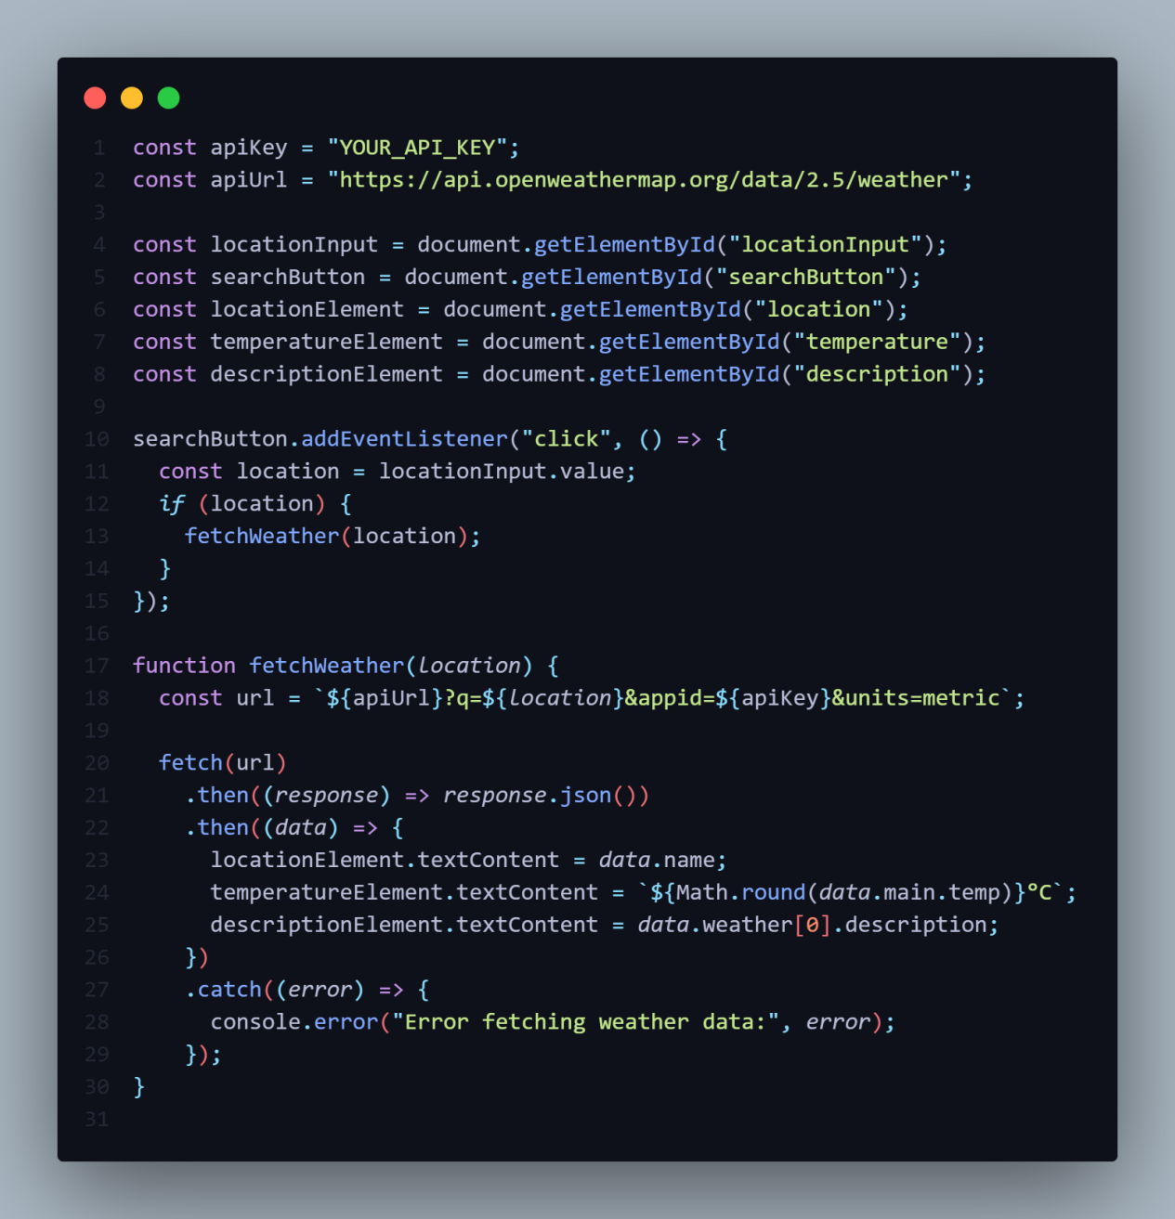

- Important: Replace YOUR_API_KEY with your actual OpenWeatherMap API key.
- The fetch API is used to send a request to the constructed URL.
- The .then method handles the successful response. Here, we'll call another .then method to parse the JSON data in the next step.
- The .catch method handles any errors during the fetch process.
Step 3: Parsing JSON Data and Updating UI
- Parse the JSON Response: Inside the successful response .then method (from step 2), we'll use JSON.parse to convert the response data from JSON format into a JavaScript object we can work with.
- Extract Relevant Weather Information: From the parsed object, we'll access specific properties containing the weather data we want to display (e.g., temperature, description, icon).
- Update the UI with Weather Data: Finally, we'll use JavaScript to dynamically update the content of the HTML elements in the weather-display section with the retrieved weather information.
Explanation:
- We parse the JSON response using JSON.parse.
- We access specific properties within the parsed data object to retrieve the temperature and weather description (replace placeholders

